MINI PROJECT

Library Management

#include<iostream> using namespace std; #include<conio.h> #include<string.h> class Library

{

private:

int member_id[5]; public:

void search_student();

};

void Library::search_student()

{

int memberid[10] = { 1000,1001,1002,1003,1004,1005,6,7,1008,1009 };

int num,index = 0;

cout << "*******Library Management*******";

std::cout << "\nThis library has 10 students with IDS from 1000-1009."; cout << "\nCheck if your member ID exists :";

std::cout << "\nEnter Member ID to be searched:"; std::cin >> num;

for (int i = 0; i < num; i++)

{

if (memberid[i] == num)

{

index = i; break;

}

}

std::cout << "\nStudent record exists"; std::cout;

}

class student

{

public:

void search_rollno();

};

void student::search_rollno()

{

int rollno[20] = { 1,2,3,4,5,6,7,78,89,11,12,13,44,15,16,77,18,29,20 };

int search,index = 0;

cout << "\nThe library keeps a record of the student's roll no.s who have enrolled for a card:";

cout << "\n Check availability from Roll No :1 to 20 "; cout << "\nEnter rollno. to be searched:";

cin >> search;

for (int i = 0; i < 20; i++)

{

if (search == rollno[i])

{

index = i;

break;

}

}

cout << "\n Student roll no exits ";

}

class Book:public Library

{

public:

void search_edition();

};

void Book::search_edition()

{

int edition[10] = { 2000, 2001, 2002,2004,2005,2006,2007,2008,2010,2009 };

int num;

cout << "\n The library keeps year wise editions of a book from 2000-2010"; cout << "\n Log into see if the edition of your book is available :";

cout << "\nEnter edition to be searched:"; cin >> num;

for (int i = 0; i < 10; i++)

{

if (num == edition[i])

{

break;

}

}

cout << "\nEdition of the book exists in the library";

}

class IssueMaintenance:public student

{

private:

int no_of_days; public:

void fine();

};

void IssueMaintenance::fine()

{

cout << "\nThe library gives notices if your book's due date is close, your book is due or if there is a fine applicable.";

cout << "\nEnter number of days since book was issued: "; cin >> no_of_days;

if (no_of_days == 15)

cout << "\nIt's time to return your book"; else if(no_of_days < 15)

cout << "\nThere is still some time until you return";

else

}

cout << "\nFine is applicable";

class Accounts:public Library

{

private:

int no_of_booksbought; double cost;

double total = 0; public:

void calculate();

};

void Accounts::calculate()

{

int num;

cout << "\nThe library sends a bill to the accounts division every month: "; cout << "\nEnter the number of books bought this month :";

cin >> no_of_booksbought;

for (int i = 0; i < no_of_booksbought; i++)

{

cout << "\nEnter cost of Book " << (i + 1) << ":"; cin >> cost;

total = total + cost;

}

cout << "\nTotal bill from the library to the accounts section :" <<total;

}

int main()

{

Library l; l.search_student(); student s; s.search_rollno(); Book b; b.search_edition(); IssueMaintenance i; i.fine();

Accounts c; c.calculate();

_getch(); return 0;

}

Output:

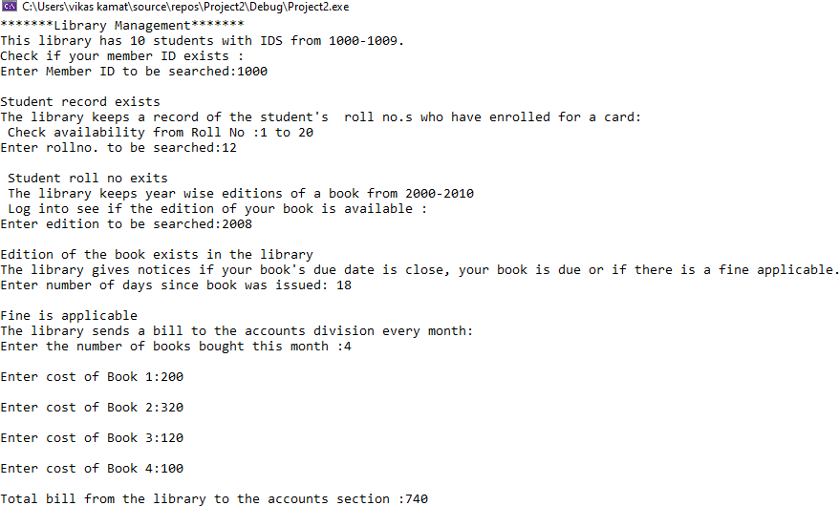

student

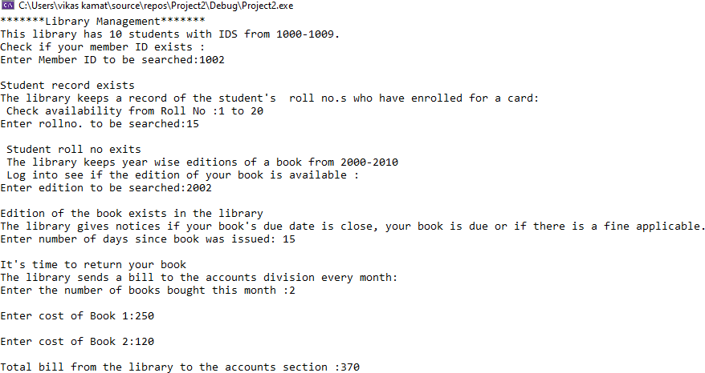

Student\